Level: ACTFL Intermediate Mid
Context: IEP, 15 students, technology enriched classroom

Topic: Count and Noncount Nouns
Previous Day: Articles: A vs. An
Students should know: parts of speech, nouns, articles, plurals, partitives (i.e., counter nouns)

Learning Outcomes:

- Students correctly identify count and noncount nouns
- Students produce correct form of count and noncount nouns in meaningful spoken context

Review/Warm Up (5 min):
Review use of articles:
Take 5 headlines from yesterday’s ksl.com news that have missing articles. Show these titles to the students. Students write the title in full sentences including any missing articles. Check answers with a partner and then together as a class.

Ex: Agreement Signed Today – An agreement was signed today.

P – Present Meaningful Language (homework: ~15 minutes)

Task:
- As you read the prompt and watch the video, write down all the ingredients that you hear. Define for the students what ‘ingredients’ means.
- Before watching the video, tell the students that the speakers in the video will talk about their favorite recipe. Ask them to write a couple of sentences responding to the following question: “What do you expect to hear in the video?” before listening to it.
https://www.youtube.com/watch?v=wHLHsFisgWg&t=71s (Start watching at 1:47 -4:58)
After listening to it, write two sentences responding to the following question: “How was what you heard similar of different than what you expected?”
- Make copies for each student for them to read as a homework assignment. https://tastesbetterfromscratch.com/funeral-potatoes/. (just the recipe) (a PDF for this is on Canvas). Ask the students to report what ingredients they do or do not like and why in a about 3 sentences.

A – Draw Attention (5 minutes)

- Talk about the ingredients needed in the recipe and point out the nouns used. Label them as count or noncount for the students, while showing this enhancement from the text.

- ▢30 ounces frozen hash browns , diced or shredded will work, THAWED*
- ▢2 cups sour cream
- ▢10.5 ounce can cream of chicken soup (or homemade)
- ▢10 Tablespoons butter , divided, melted
- ▢1 teaspoon salt
- ▢1/4 teaspoon freshly ground black pepper
- ▢1 teaspoon dried minced onion
- ▢2 cups shredded cheddar cheese
- ▢2 cups corn flakes cereal

Ingredients:
Hash browns – count
Sour cream – noncount
Cream of chicken soup -count
Butter – noncount
Salt – noncount
Black pepper – noncount
Onion – count
Cheese – count and noncount*
Cereal – count and noncount*

Counter words:
All count
Ounce
Cup
Can
Tablespoon
Teaspoon

*I need to buy two bags of cheese from the store.
There is a variety of cheeses on the table.
*I like to eat cereal for breakfast.
I have a variety of cereals in my cupboard.

- For the video,

Fresh or jarred (canned) vine leaves -count
Minced pork (ground pork) - noncount
Ground meat - count and noncount
Peppers - count
Oil - noncount
Onion - count
Vegetables - count
Seasonings - count
Salt - noncount
Pepper - noncount
Cinnamon - noncount
Dried mint - noncount
Parsley -noncount
Rice - noncount
Chopped tomatoes - count
Lemon juice – count and noncount
Lemon – count

C—Co-construct (10 minutes)

- Ask the students, some of the following questions to get them to help construct the meaning and use count/noncount nouns
  - Based on our examples, what is a count noun? What is a noncount noun?
  - What kind of words are countable? What kinds of words are not countable?
  - How does being count/noncount affect how we count them?
  - How does being count/noncount affect how we make the word plural?
  - How does being count/noncount affect how we use articles?
  - Are there any words that could be both count and noncount? Why?

Here are more examples if you need them:

I saw two chairs at the store that I would like to buy, but they are too expensive.
The furniture I bought today will be delivered in a week.

My mom likes jewelry, so I bought her a ring and two necklaces for her birthday.

- Rules for count/noncount nouns that you are trying to help them construct:

Count nouns:

- can be preceded by an article (a, an) in the singular form
- receive an -s or -es at the end in the plural form
- can be counted using numbers (one chair, two chairs)

Noncount Nouns:

- cannot be immediately preceded by an article (a, an)
- does not have a plural form (no -s or -es at the end)
- cannot be counted using numbers
- refer to a whole group made up of individual parts (count nouns) Ex: furniture (chairs, beds, tables, desks, etc.)

E – Extension Activities

In class
- Practice 1 (~10 minutes)
On the board, make two columns (count and noncount). Give your students 10 sticky notes each. Have them write down 10 (5 count and 5 noncount) nouns that are not foods (one on each sticky note). Then, they go to the board and put stick them under the correct category.

- Practice 2 (~10 minutes)
Students work with a partner. Teacher prepares several noncount nouns on small slips of paper. Give each partnership 6 slips of paper with nouns face down. Students take turns choosing a slip of paper and flipping a coin. They create sentences using the noun in the plural or singular depending on heads or tail (heads = singular; tails = plural). For example, if the student flips a tails and pulls the noun furniture, she could say, “I bought three pieces of furniture from the store.”

Here is a list of nouns to use:
Non-count
- Tennis
- Jewelry
- Wood
- Information
- Sand
- Money
- Work
Count
- Box
- Tree
- House
- Person
- Necklace
- Truck
- Movie

- Practice 3 (~10 minutes)
Show the students a series of pictures of meals/dishes that have multiple ingredients. In small groups, have the students list out all of the ingredients that they can think of for those meals/dishes. Then, they list out the ingredients as if they were for a recipe (i.e., including the amounts). Here are some images as examples.
PIZZA


THANKSGIVING DINNER
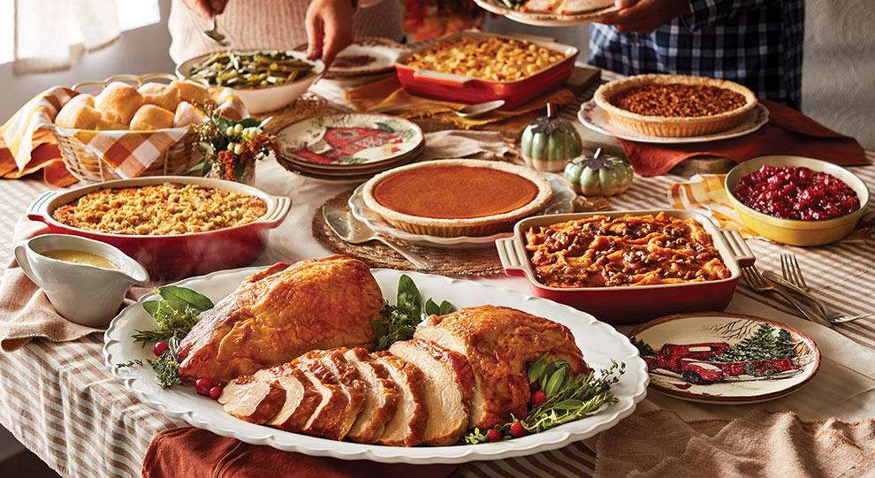

SALAD
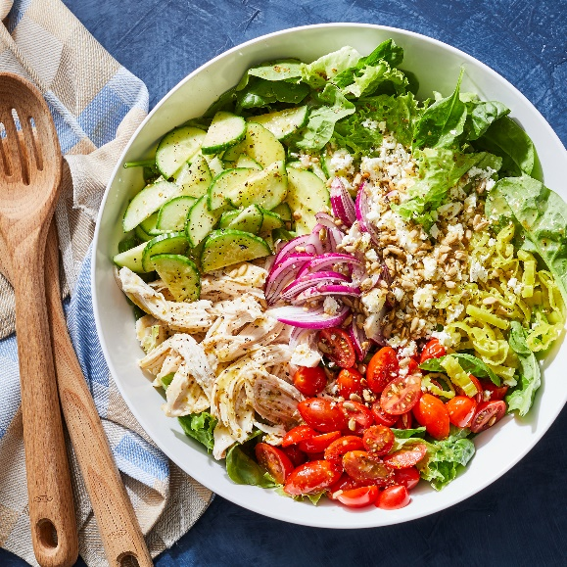
Homework activity (15 minutes)
- Provide a list of common quantities used in cooking
Ex.
Cup
Can
Bowl
Tablespoon
Teaspoon
A bundle of
Half a cup
A quarter of a cup
Three quarters of a cup

- Assign students the following prompt as homework:
Think of two of your favorite recipes. Make a list of all the ingredients you need to make it. Make sure to include all the quantities. For example: 1 cup of sugar, 1 teaspoon salt, etc. When you come to our next class, for our warmup, discuss the recipes with a partner making sure to share the list of ingredients (using the singular and plural forms). Feel free to share photos and talk about when it is appropriate to make and eat this dish.

For a more comprehensive list of common noncount nouns, you can access the following link:
https://academicguides.waldenu.edu/writingcenter/grammar/nouns

